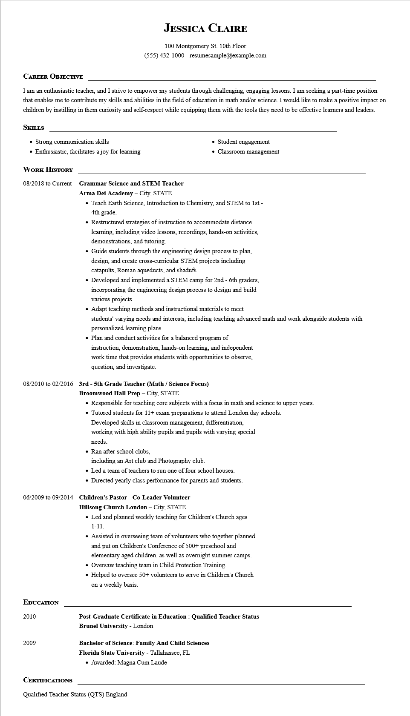
JESSICA CLAIRE
100 Montgomery St. 10th Floor (555) 432-1000 - resumesample@example.com
CAREER OBJECTIVE
I am an enthusiastic teacher, and I strive to empower my students through challenging, engaging lessons. I am seeking a part-time position that enables me to contribute my skills and abilities in the field of education in math and/or science. I would like to make a positive impact on children by instilling in them curiosity and self-respect while equipping them with the tools they need to be effective learners and leaders.
SKILLS
• Strong communication skills
• Enthusiastic, facilitates a joy for learning
WORK HISTORY
• Student engagement
• Classroom management
08/2018 to Current
Grammar Science and STEM Teacher
Arma Dei Academy - City, STATE
• Teach Earth Science, Introduction to Chemistry, and STEM to 1st - 4th grade.
• Restructured strategies of instruction to accommodate distance learning, including video lessons, recordings, hands-on activities, demonstrations, and tutoring.
• Guide students through the engineering design process to plan, design, and create cross-curricular STEM projects including catapults, Roman aqueducts, and shadufs.
• Developed and implemented a STEM camp for 2nd - 6th graders, incorporating the engineering design process to design and build various projects.
• Adapt teaching methods and instructional materials to meet
students' varying needs and interests, including teaching advanced math and work alongside students with personalized learning plans.
• Plan and conduct activities for a balanced program of
instruction, demonstration, hands-on learning, and independent
work time that provides students with opportunities to observe, question, and investigate.
08/2010 to 02/2016 3rd-5th Grade Teacher (Math / Science Focus)
Broomwood Hall Prep - City, STATE
• Responsible for teaching core subjects with a focus in math and science to upper years.
• Tutored students for 11+ exam preparations to attend London day schools.
Developed skills in classroom management, differentiation,
working with high ability pupils and pupils with varying special
needs.
• Ran after-school clubs,
including an Art club and Photography club.
• Led a team of teachers to run one of four school houses.
• Directed yearly class performance for parents and students.
06/2009 to 09/2014 Children's Pastor - Co-Leader Volunteer Hillsong Church London - City, STATE
• Led and planned weekly teaching for Children's Church ages 1-11.
• Assisted in overseeing team of volunteers who together planned and put on Children's Conference of 500+ preschool and elementary aged children, as well as overnight summer camps.
• Oversaw teaching team in Child Protection Training.
• Helped to oversee 50+ volunteers to serve in Children's Church on a weekly basis.
EDUCATION
2010
2009
CERTIFICATIONS
Post-Graduate Certificate in Education: Qualified Teacher Status Brunel University - London
Bachelor of Science: Family And Child Sciences
Florida State University - Tallahassee, FL
• Awarded: Magna Cum Laude
Qualified Teacher Status (QTS) England

